Tentative title: Molecular diversity informed modelling of litter decomposition

Arjun Chakrawal1, Stefano Manzoni2, Emily Graham1, Satish Karra1, Odeta Qafoku1, John Bargar1?

1Environmental Molecular Sciences Laboratory, Pacific Northwest National Laboratory, Richland, WA, USA

2Department of Physical Geography and Bolin Centre for Climate Research, Stockholm University, 10691 Stockholm, Sweden

**Abstract:**

**Keywords:**

chemodiversity, decomposition, 13C NMR, plant litter, degree of reduction, carbon use efficiency

# Introduction

Integrating biogeochemical and nutrient (carbon–C, nitrogen-N, phosphorous-P) cycle in models coupled with emerging molecular data on the chemical composition of organic matter has struggled to keep pace with the rapid generation of new molecular-scale data (?) information. In terrestrial ecosystems, the application of high-resolution mass spectrometry techniques such as Nuclear Magnetic Resonance (NMR) and Fourier Transform Ion Cyclotron Resonance mass spectroscopy (FTICR-MS) is frequently used for elucidating the chemical composition at molecular scale (?) of organic matter in soils (Boye et al., 2017; Dignac et al., 2002; Ding et al., 2020; Hall et al., 2020; Normand et al., 2021; PRESTON et al., 1987), plant litter (G. Bonanomi et al., 2013; Preston et al., 2000), and microbial biomass (Hedges et al., 2002; Knicker and Lüdemann, 1995). However, despite the insights gained from molecular observations, there remains a critical gap in ecosystem-scale models simulating biogeochemical exchanges informed by molecular-scale processes. For example, while solid-state 13C NMR has been extensively utilized to explore the influence of plant litter quality on its degradation, the direct integration of NMR data into litter decomposition models remains scarce. In this study, we present a novel approach to litter decomposition model that is informed and constrained using solid-state 13C NMR data.

The complex and heterogeneous structure of lignin in plant cell walls provides a protective barrier for high-energy unbranched carbohydrates, such as cellulose, and cross-linked polysaccharide chains, like hemicellulose, that are housed within plant cells. These lignin compounds shield carbohydrates as well as proteins from microbial decomposition. Certain specialized decomposer organisms, including white-rot fungi and Agaricomycetes, have oxidative enzymatic capabilities that can break down lignocellulosic bonds in plant cell walls, releasing polysaccharides for microbial growth and respiration (Alcalde, 2015; Mattila et al., 2022). However, cost of oxidative enzyme production requires significant resource investment by microbes that would otherwise be used for growth (Moorhead et al., 2013; Shimizu et al., 2005). This trade-off between resource investment and access to high-energy substrates has been modeled using a rate modifier that decreases the uptake rate of carbohydrates and proteins with increasing lignin content in plant litter. Corresponding costs of producing oxidative enzymes is modeled as reduction in C use efficiency of microbial community (Manzoni et al., 2021; Moorhead et al., 2013).

The development of models capturing this shielding effect started with the finding by Moorhead et al. (2013) that decay rates of holocellulose (cellulose and hemicellulose) decrease while those of lignin increase with the lignocellulose index (lignin/(lignin + holocellulose)) during litter decomposition. This led to development of a rate modifier as a function of lignocellulose index and has been applied in LIDEL (Campbell et al., 2016) and MEMS models (Robertson et al., 2019). Building on Moorhead et al. (2013), Manzoni et al. (2021) employed a power law function to incorporate the diminishing rates of carbohydrates and protein pools in their model. Recently, Chakrawal et al. (2024) utilized an exponential function as a rate modifier that was constrained using lignin fraction derived from 13C NMR spectra data. We are aware of only one other study by Incerti et al. (2017) that directly utilizes 13C NMR data to inform and constrain a litter decomposition model, termed OMDY (organic matter dynamics). The rate modifier in the OMDY model is referred as an intramolecular protection function that decreases the rate of simulated litter pools with increasing fractions of pools considered to have a protective effect. OMDY considered four litter pools in based on four molecular group identified from 13C NMR spectra chemical shift regions—alkyl C (0–45), methoxy and N-alkyl C (46–60), O-alkyl C (61–90) and di-O-alkyl C (91–110)—of which alkyl C, O-alkyl C and di-O-alkyl C were found to have protective effect.

Historically, litter decomposition models have been parameterized using C and N mass loss data, augmented with chemical composition data obtained from proximate analysis, i.e., (state the type of analysis) (Campbell et al., 2016; Liski et al., 2005; Manzoni et al., 2021). The acid unhydrolysable and hydrolysable fractions from proximate analysis of plant material have been used as proxies for lignin and carbohydrates, respectively, despite their potential inaccuracies in representing actual carbohydrate and lignin fractions (Preston and Trofymow, 2015). In fact, using proximate analysis for parameterization of the rate modifier function has posed significant challenges particularly due to measurement errors inherent in quantifying lignin and carbohydrates. Furthermore, we ask whether such rate modifier and associated cost of oxidative enzyme production would be required as additional model parameters if the litter pools are comparatively more refined than existing models; thus, raising questions on the use of rate modifier. Therefore, there is a need to develop a litter decomposition model that can be informed using detailed molecular scale chemical composition and mass loss data.

In this contribution, we demonstrate the integration of molecular-scale chemical composition of plant litter, specifically utilizing solid-state 13C NMR, to constrain coupled C and N litter decomposition models. Specifically, we aim to assess the efficacy of 13C NMR data in calibrating four model scenarios simulating litter decomposition with and without the protection of effect of lignin on carbohydrates and proteins decomposition, and with trade-offs in microbial C use efficiency. Our specific research question are as follows,

1. Can we use 13C NMR data to constrain litter decomposition model parameters?
2. Does lignin rate modifier improve calibration of the model?
3. How do estimated parameters vary across four model scenarios constraints using same dataset?

# Methods

## Data collation and preparation

We searched published literature for litter incubation studies reporting litter total C and N mass loss and spectra from solid state 13C NMR over time. The list of collected references are provided in Table XX, a total of XX studies spanning XXX different geographies/environments. Not all studies reported all data at each time points, for instance, 13C NMR data was not always available for each time point of mass loss data. We note that, the 13C NMR data is usually reported as integrated values of seven chemical shift regions representing various functional groups of organic C present in the litter sample (Figure 1A) that correlates well with macrochemical composition of litter. For example, the sum of di-O-alkyl and O-alkyl is indicative of carbohydrates, while aromatic and phenolics are indicatives of lignin like compounds and so forth, refer to (Kögel-Knabner, 2002). The integrated values of seven chemical shift regions are often respectively normalized with the total area under the spectra thus representing the fraction of C of each functional group in total C of litter. The integrated chemical shift data can be transformed into fraction of five distinct molecular classes of compounds comprising litter sample using a molecular mixing model (Nelson and Baldock, 2005). These classes are carbohydrates, proteins, lignins, lipids, and carbonyls. In the following section, the molecular mixing model is described.

Data that don’t report C conc 500mg/g litter were assumed. More details on fitting from python file

## Molecular mixing model

Assuming plant litter sample is made up of carbohydrates, proteins, lignin, lipids, and carbonyls organic compounds, molecular mixing model estimates fractions of each class such that the observed solid state 13C NMR spectra of whole litter sample is a weighted sum of the spectra of the organic compounds (Figure 1A). The elemental composition of these organic compounds is fixed (see Table X). Thus, the input data required for molecular mixing model is the observed integrated values of chemical shift regions of litter sample () and the organic compounds (). Let us denote the C fractions of molecular classes as in the units of gC per gC of litter, where is carbohydrates, proteins, lignin, lipids, or carbonyls. Mathematically, the molecular mixing model can be written as,

|  |  |  |
| --- | --- | --- |
|  |  | () |

where is a matrix of size [] whose rows are the NMR spectra of seven chemical shift regions of five organic compounds, is column vector of size [] containing fraction of five organic compounds, and is a column vector of size [] containing observed integrated values of seven chemical shift regions of litter sample. Equation (1) is solved for using total C and N concentration of litter as constraints to conserve mass balance. If CN ratio (gN /gC) of plant litter was reported, then protein fraction is constrained using N mass balance i.e., where is the CN ratio of proteins—indicating total N content of litter is in proteins. For more details on molecular mixing model see Chakrawal et al 2024 (in preparation). The molecular mixing model is used at each time point to convert NMR chemical shift data to C fraction of carbohydrates, proteins, lignin, lipids, and carbonyls which can be converted into mass unit (gC) multiplying by the total litter C (gC). We used scipy.optimize.minimize function with mass balance constraints to solve for . Toassess molecular mixing model performance, we calculated R-squared and root mean squared (RMSE) values as goodness of fit metrices between observed NMR of litter and estimated NMR calculated using estimated (Figure 2B).

## Litter decomposition model

We developed a litter decomposition model for simulating the dynamics of C and nitrogen (N) within five distinct pools representing organic compounds as identified from the molecular mixing model using NMR data (Figure 1B). We assumed first order kinetics for the uptake rate () of each pool, which is reasonable when using coarse resolution data spanning months-to-years. The protection effect of lignin on carbohydrates and proteins is implemented using a sigmoidal function () that decreases with increasing fraction of lignin similar to Chakrawal et al. (2024). Further, we assumed that assimilated substrates can be used for growth and maintenance at a maximum C use efficiency (). The maximum CUE decreases with increasing decay constant for the lignin fraction in the case of model accounting for the investment into oxidative enzyme production (Manzoni et al., 2021). Under N-limited conditions, we assumed that microorganism regulate their CUE resulting in overflow respiration, also resulting in decreased CUE (Sinsabaugh et al., 2013). Further, we assume that microorganisms are growing in a quasi-steady state condition, meaning their growth rate equals mortality rate. The necromass is recycled into various organic compound classes according to its composition. In the model, necromass turnover rate is distributed across compound classes using fixed fractions.

Based on these, we can write the mass balance equation for each organic compound as follows,

|  |  |  |
| --- | --- | --- |
|  |  | () |

where, is the mass of C in each pool, = or for carbohydrates, proteins, lignin, lipids, and carbonyls. The is the rate modifier affecting the rate constant of different pools. For carbohydrates and proteins pool, , capturing the protection effect of lignin; for lignin capturing the effect of delayed decomposition of lignin in lignin-poor litter; for lipids and carbonyls indicating time invariant rate constants. The coefficients are the fraction of microbial mortality rate , recycling into respective pools. Next, the mass balance for microbial C () is written as follows,

|  |  |  |
| --- | --- | --- |
|  |  | () |

where, the first term on the right-hand side is the microbial growth rate , with as the C use efficiency (ratio of growth over total uptake rate) under C limited conditions. The cost of oxidative enzyme production is modeled as , where is the cost factor.

Following Chakrawal et al. (2024), we formulated the rate modifier as decreasing function of lignin fraction, and is given as , where is the fraction of lignin C and is the scaling coefficient. For brevity we refer to this rate modifier as -function. In Chakrawal et al. (2024), the value of scaling coefficient was estimated to be for aromatic C. By scaling aromatic C to lignin C in -function (approximating, 55% of lignin is aromatic C ), we estimated . Further, we assumed a quasi-steady state assumption for microbial growth, , so that .

The uptake rate of each pool is prescribed using first-order kinetics with as rate constant, and written as follows,

|  |  |  |
| --- | --- | --- |
|  |  | () |

Assuming that necromass recycling into the protein pool has the same CN ratio as of the protein pool, we can write the N mass balance for protein pool,

|  |  |  |
| --- | --- | --- |
|  |  | () |

Note that eq (5) is redundant as it can be written as Next, the mass balance for microbial N () is written as follows (recall that N is only coming from protein pool),

|  |  |  |
| --- | --- | --- |
|  |  | () |

where, is the CN ratio of microbes and is the net N exchange rate from inorganic pool. The coefficient is the N retention factor. Imposing the homeostatic condition for microbial growth, i.e., , we calculate as follow,

|  |  |  |
| --- | --- | --- |
|  |  | () |

Replacing with from the quasi-steady state assumption for microbial growth, we obtain as

|  |  |  |
| --- | --- | --- |
|  |  | () |

The first term on the right-hand side is supply of N from protein pool and the second term is the N demand for microbial growth. If net N mineralization occurs and if then net N immobilization from inorganic N pool occurs. We define N limited microbial growth when net immobilization rate is higher than supply of N from inorganic pool, i.e., . Thus, under N limited condition, N uptake from inorganic pool is fixed at supply rate of N from inorganic pool, i.e., . Furthermore, we assume that microorganism selectively retain N on turnover under N limited conditions by reducing . Following, Manzoni et al (2021), we use as N retention factor that reduces . Using constraint, we can calculate the value of , as follows,

|  |  |  |
| --- | --- | --- |
|  |  | () |

The N retention factor varies between minimum under C limited condition to a theoretical maximum . The fraction of necromass recycled into protein N pool must be the same, therefore, is estimated using following constraint from Eqs () and (),

|  |  |  |
| --- | --- | --- |
|  |  | () |

Simplifying, we get implying that <1, so that most of the C from necromass will be recycled in the C-only pools, while all the N is recycled in the protein pool. The decrease in under N limited conditions were associated with increased microbial turnover in carbohydrate pool i.e., .

As an alternate strategy, microbes can reduce their CUE to reduce N demand under N limited conditions. In this case, we assume there is not N retention, thus, . As above, using constraint, we can calculate a new CUE as follows,

|  |  |  |
| --- | --- | --- |
|  |  | () |

## Model parametrization:

### Four model scenarios

We defined four model scenarios, each tailored to explore specific facets of the interaction between lignin protection of carbohydrate and protein pools and the ensuing impact on CUE resulting from investments in oxidative enzymes. The first model scenario, referred to as "No protection, no enzyme cost," posits that the degradation rates of carbohydrates and proteins remain uninfluenced by lignin content, while microorganisms operate at max CUE without incurring additional costs from enzymatic activities. This is achieved by setting the value of for all pools. The second model scenario, the "No protection, with enzyme cost" model maintains unaltered decomposition rates for carbohydrates and proteins despite the presence of lignin, but assumes an investment towards oxidative enzyme production, leading to a proportional reduction in CUE. This scenario is motivated from the production of ligninolytic enzymes for uptake of lignin like compound for growth and maintenance (del Cerro et al., 2021). In this scenario of the model, the - function is set to 1 only when multiplied to rate constants. The third model scenario "Protection (time invariant ), with enzyme cost" integrates both lignin's protective effects and the accompanying costs of oxidative enzymatic activity. In these three model scenarios we assume that , thus, the rate constant of lignin is assumed invariant. Finally, in the fourth model scenario, "Protection (time variant ), with enzyme cost", is similar to third model but with time variant lignin rate constant by setting .

### Model implementation and Least-square model-data fitting

The final litter decomposition model only consisted of five mas balance equations (eq (2)) for five organic compounds that needs to be solved. These systems of ordinary differential equations were solved using an iterative solver. The model has five rate constants , five mortality fractions , inorganic N supply rate, , oxidative enzyme cost factor the scaling coefficient , , and initial conditions of five pools as unknown parameters.

The maximum CUE, is constrained using oxidation state of litter C (Chakrawal et al., 2022) and varies dynamically. The oxidation state of litter is estimated as weighted sum of oxidation state of each organic compound (see Table (XX)). Following, Manzoni et al. (2021), we parametrizes the cost factor assuming higher cost for related to low oxidative capacity, thus, . Furthermore, Chakrawal et al. (2024) also found an inverse relationship between the cost factor and lignin rate constant (see supplementary Figure S3 from (Chakrawal et al., 2024)).

The CN ratio of microbes are assumed to be 10 and of proteins 3.2. The fraction of necromass recycling into protein pool using eq (10), yields = 0.32, and other fractions recycling into lignin and lipid, carbonyl pools were estimated using composition of fungal necromass from Beidler et al. (2020) as 5,, and , and finally necromass fraction recycling to carbohydrate pool yields . The scaling coefficient as described in section 2.3. The initial condition for organic compounds were directly set from observed data using initial fractions. The inorganic N supply rate, was estimated as maximum measured rate of N accumulation for each litter incubation. The remaining five rate constants were estimated as best-fitted parameter by least-square method using observed time series data of carbohydrates, proteins, lignins, lipids, and carbonyls pools obtained from molecular mixing model by processing NMR data. We used scipy.optimize.least_squares for fitting the model to data, coefficient of determination (R-squared) and root mean squared error (RMSE) as model performance metrices and Akaike information criterion to evaluate four model scenarios. More details on fitting from python file

## Statistical analyses

Should we do a statistical test to see if we can find negative correlation among carbohydrate, protein rates with lignin fraction using estimated parameters from different model fits. Idea would be to test if estimated parameters account for the protection effect lignin when model is explicitly accounting for such effects vs when model is not.

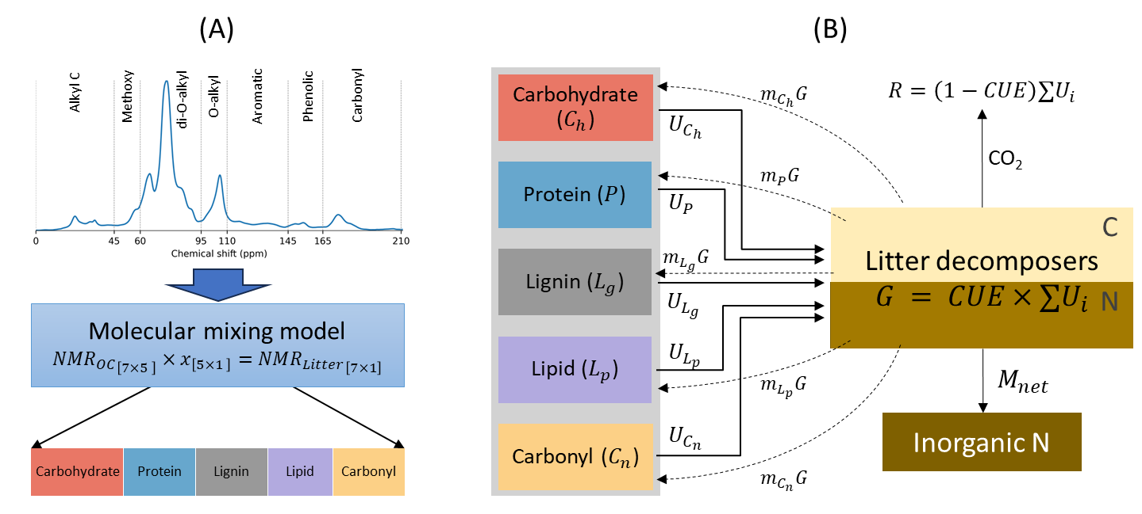

Figure 1 (A) Observation model schematic illustrating the preprocessing of solid-state 13C NMR spectra through a molecular mixing model to derive fractions of five major components of litter, namely, carbohydrate, protein, lignin, lipid and carbonyl. (B) Litter decomposition model schematic wherein microbes decompose various litter components with an overall carbon use efficiency (CUE). Solid and dashed lines denote substrate uptake rates () and microbial mortality rates () of respective pools, where = ( or ), is the microbial growth rate, is the fraction of necromass recycled into pools, and in denote carbon in mass units (gC). is the net N exchange rate from inorganic N pool (I think we discussed about this, but how is this calculated, perhaps you can add this here, same with CO2 - respiration).

# Results

Model exploration: Variation of DR with decomposition, transition from C to N limited condition, and its effect on CUE.

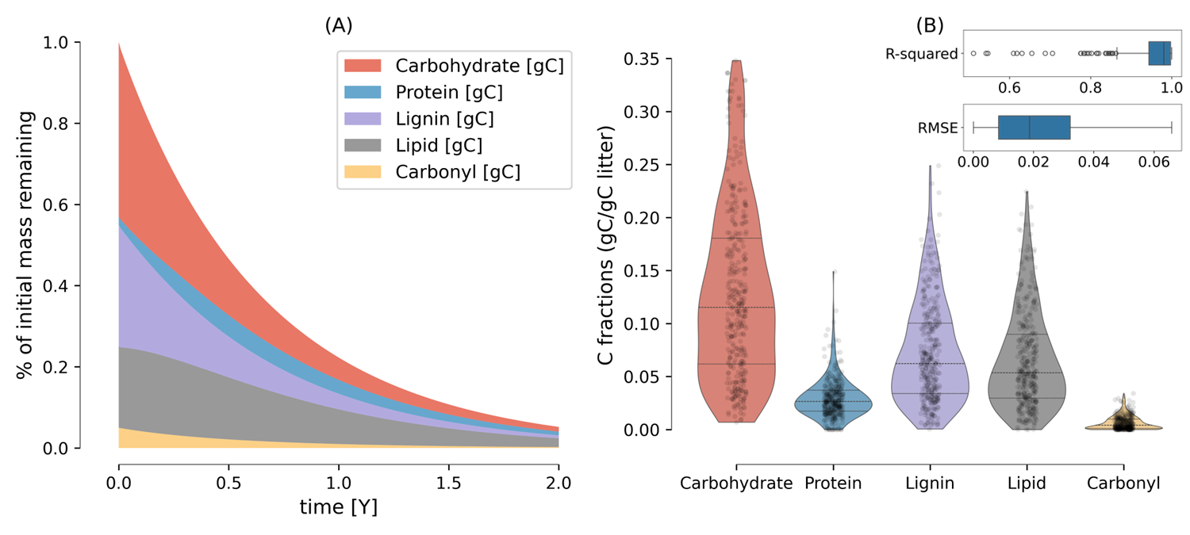

Figure 2. Changes in pool sizes with time ( in years) during decomposition simulated with Model scenario 1 (A), and range of variation (in terms of C fraction) of five organic compounds in litter estimated from molecular mixing model using 13C NMR data collected from literature (B). The inset in panel B, shows the R-squared and root mean square error (gC/gC litter) from the predicted NMR chemical shift using molecular mixing model and observed NMR chemical shift for compiled litter samples. The horizontal lines in the violin plots indicate quartiles: the median (middle line), upper quartile (Q3) and lower quartile (Q1). Model parameter used in panel A are [0.01, 0.01, 0.008, 0.006, 0.01] d-1, and =1e-5 gN d-1.

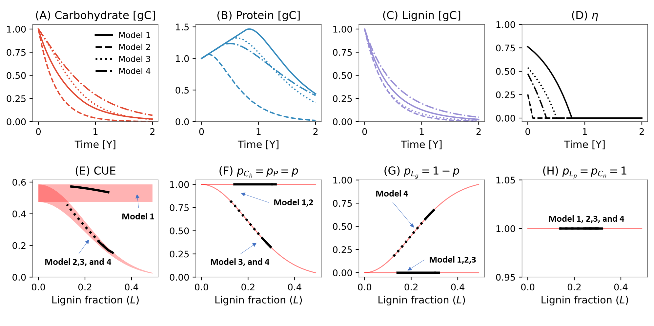

Figure Simulated variation in carbohydrate (A), protein (B), lignin pool (C), and the N retention factor, (D) with time for four model scenarios illustrated using different line styles. The bottom panels show the variation with lignin fraction of C use efficiency (CUE) (E), rate modifier for carbohydrate () and protein () (F), lignin rate constant ( (G), and rate modifiers for lipid () and carbonyl pools () (H). In panel E, the red area illustrates the range of variation in CUE under model scenarios 2, 3, and 4, calculated based on a minimum and maximum degree of reduction of whole litter, set at 3.8 and 4.5, respectively, to determine . In panels F, G, and H, the red lines extend the range of variation of rate modifiers with lignin fraction. Model legends are as follows, model 1: no protection of carbohydrate and protein, and no oxidative enzyme cost, model 2: no protection of carbohydrate and protein but with oxidative enzyme cost, model 3: protection of carbohydrate and protein with oxidative enzyme cost but time invariant lignin rate constant, model 4: protection of carbohydrate and protein with oxidative enzyme cost but time variant lignin rate constant. Model parameters used for simulations are same as in Figure 2.

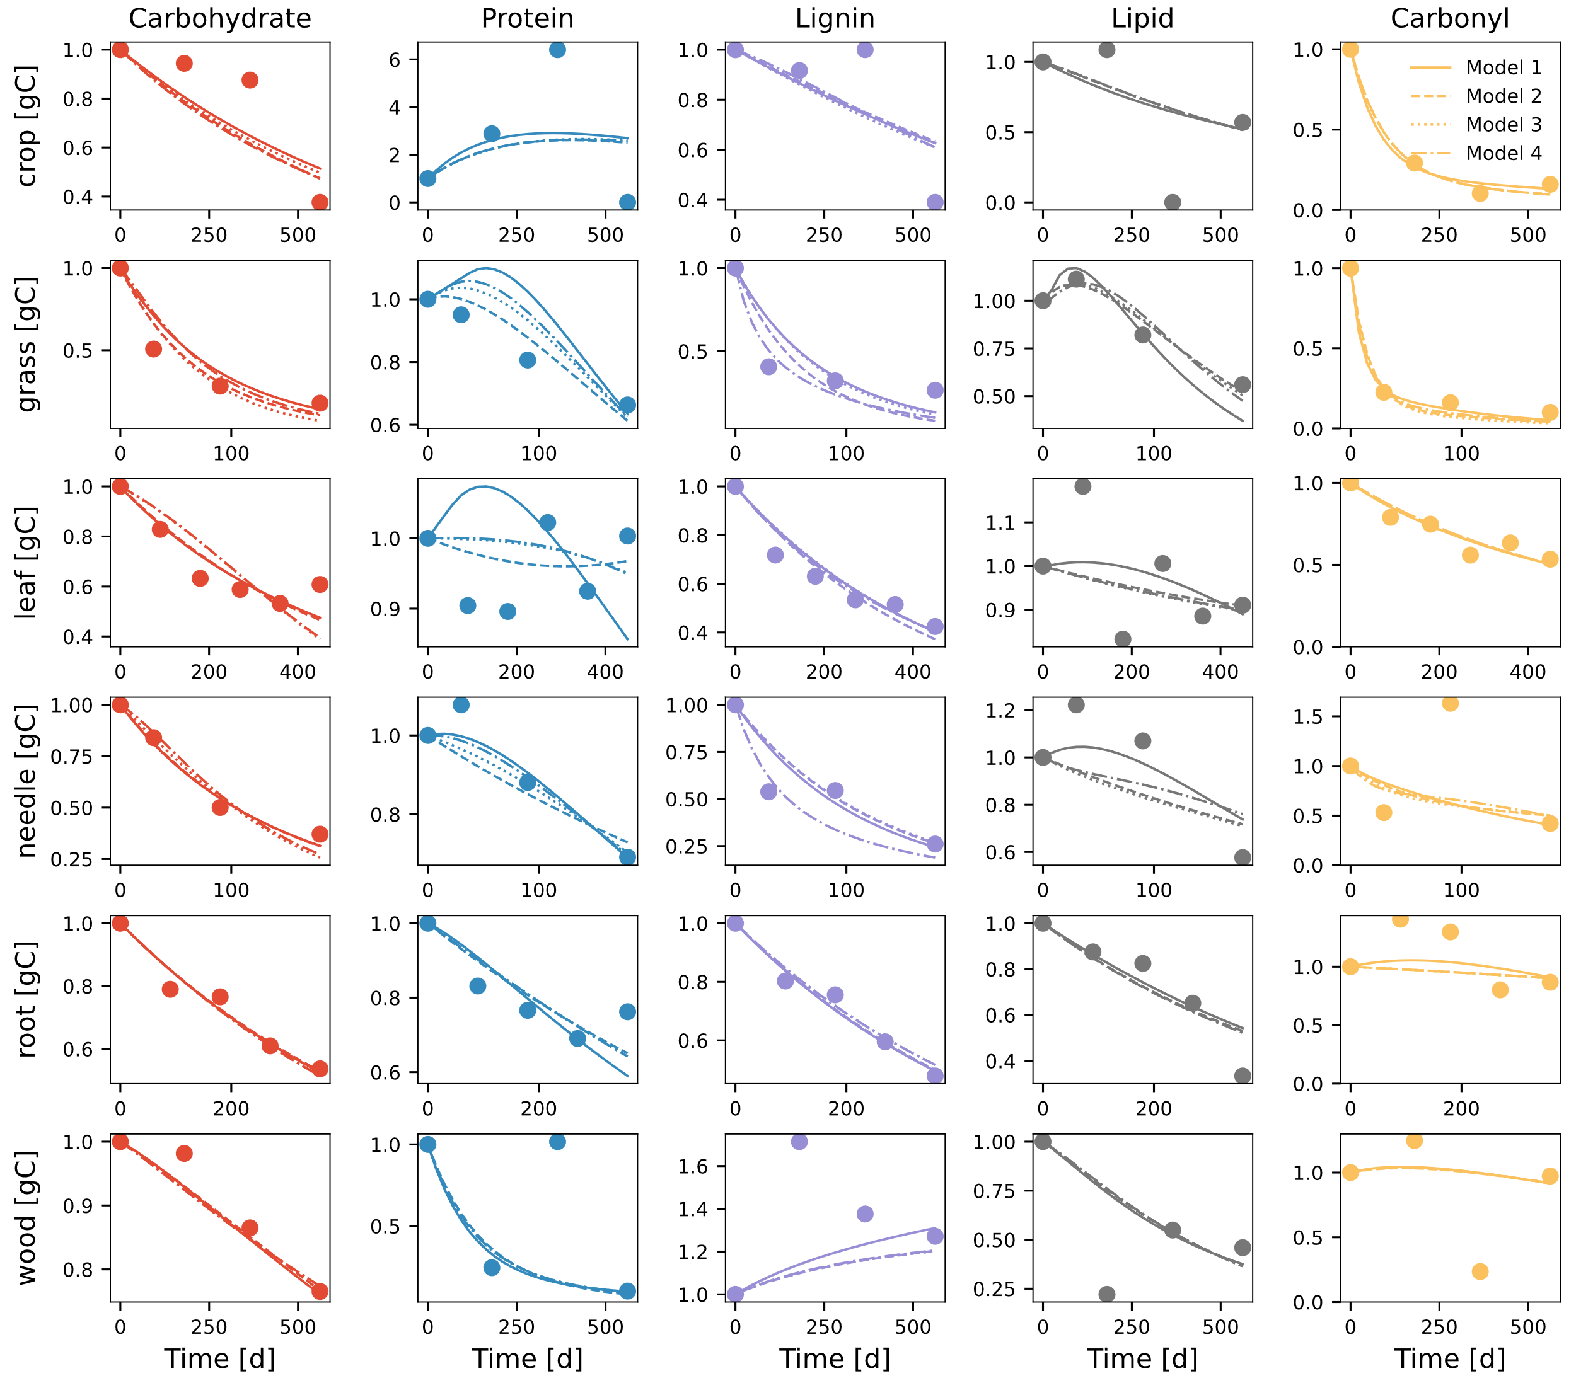

Figure 4 Comparison of modeled (different line styles) and observed (circles) changes in five litter pools (carbohydrate, protein, lignin, lipid, and carbonyl) for various litter types. The data points for the crop and wood litter samples are from wheat and Mulga twigs, respectively, from Mathers et al. (2007); for grass and needle litters samples are of A. mauritanicus and P. excelsa, respectively, from Bonanomi et al. (2013); for leaf litter samples from Eucalyptus from Wang et al. (2019); and the root litter samples are fine roots of P. massoniana from (2013). Different line styles are for four model variants. Model legends are the same as in Figure 3**.**

Figure 5 (A) Comparison of modeled and observed mass remaining of carbohydrate, protein, lignin, lipid and carbonyl among three model scenarios illustrate using different colors. The inset axis compares modeled and observed degree of reduction calculated. The grey line represents 1:1 line. Model performance metrices, the coefficient of determination, R-squared (B), and root mean square error (C) between a vector modeled and observed containing mass remaining from all pools among three model scenarios. Model legends are the same as in Figure 3**.**

Figure 6 Distribution plot of estimated model parameters, i.e., the uptake rate constant for (A) carbohydrate, (B) protein, (C) lignin, (D) lipid, and (E) carbonyl for three model scenarios as different line styles. Note the log transformed value on X-axis for each variable. Distribution plots illustrated by black and purple lines in panels A, B and C are the rates of carbohydrates, proteins, and oxidizable (representative of lignin) pools, respectively, taken from Manzoni et al. (2021), and nonaromatic (representative of carbohydrates and proteins) and aromatic (representing lignin and other aromatic compounds) pools from Chakrawal et al. (2024). Model legends are the same as in Figure 3**.**

Figure 7 Variation in initial and temporal average carbon use efficiency (A) and degree of reduction (B) for three model scenarios.

# Discussion:

How did we answer the research questions:

1. Can we use NMR data to constrain litter decomposition model parameters?

Coupled CN litter decomposition models have not been parametrized using NMR data. As microbes decompose litter, easily degradable food is lost faster, and litter is left with higher proportion of lignin like compounds which require costly oxidative enzyme that microbes can’t afford because high energy food is not available to compensate for anymore. This can be thought of as reducing return of framework.

1. Does lignin rate modifier improve calibration of the model?

If not, then why worry so much about parametrizing it? There are papers arguing that lignin does not decreases carbohydrate decomposition. Lignin is not the bottleneck. (but it depends) Yes, there are resources invested into oxidative enzyme but the presence of lignin per se may not exert decomposition limitation on carbohydrates. And if there are not enough labile high energy substrate to fuel those resource investments then microbial growth will be limited which will reduce the decomposition of all pool not just lignin. This is same as the priming effect in soils. Conceptually the rate modifier is same as return-on-investment principle.

Conceptually, the rate modifiers are similar to return-on-investment function expressed as the total substrate uptake capacity per unit cost of enzyme investment (Chakrawal et al., 2024; Wutzler et al., 2017). For example, in soil ecosystems, the energetic return on investment diminishes with depth as the energy content of organic matter decreases, while the activation energy of decomposition, in the form of exoenzymes, increases with depth. Use (Rovira et al., 2008) for litter energetics. Link to priming?

1. How does estimated parameters vary across three different models when constraints using same dataset?

Bring the issue of equifinality in model, models may fit the data equally well but perhaps for very different reasons.

## Model performance with NMR data vs proximate

Model performance, discuss OMDY

## Parametrizing protection effect of lignin/lipids on sugars and proteins

Does rates of sugars and protein decreases with lignin, lipid content?

## Variation in overall NOSC of litter during its degradation

Ideas from Gunina and Kuzyakov 2021, that as microbes decompose litter their nosc decreases

# Similarities of model developed here to be used in soils

With lipids being explicitly modeled, it will be easier to track storage part of microbial biomass?

# Conclusions

Accurately implementing such microbial controls on decomposition processes is paramount for improving partitioning of litter into soil organic matter. NMR data provide detailed and quantitative information on litter chemical composition opposed to traditional macrochemical indices use to describe litter quality such as carbon to nitrogen, nitrogen to lignin ratios.

# References

Alcalde, M., 2015. Engineering the ligninolytic enzyme consortium. Trends Biotechnol. 33, 155–162. https://doi.org/10.1016/j.tibtech.2014.12.007

Baldock, J.A., Masiello, C.A., Gélinas, Y., Hedges, J.I., 2004. Cycling and composition of organic matter in terrestrial and marine ecosystems. Mar. Chem., New Approaches in Marine Organic Biogeochemistry: A Tribute to the Life and Science of John I. Hedges 92, 39–64. https://doi.org/10.1016/j.marchem.2004.06.016

Beidler, K.V., Phillips, R.P., Andrews, E., Maillard, F., Mushinski, R.M., Kennedy, P.G., 2020. Substrate quality drives fungal necromass decay and decomposer community structure under contrasting vegetation types. J. Ecol. 108, 1845–1859. https://doi.org/10.1111/1365-2745.13385

Bonanomi, G, Gaglione, S., Incerti, G., Zoina, A., 2013. Biochemical quality of organic amendments affects soil fungistasis. Appl. SOIL Ecol. 72, 135–142. https://doi.org/10.1016/j.apsoil.2013.06.007

Bonanomi, G., Incerti, G., Barile, E., Capodilupo, M., Antignani, V., Mingo, A., Lanzotti, V., Scala, F., Mazzoleni, S., 2011. Phytotoxicity, not nitrogen immobilization, explains plant litter inhibitory effects: evidence from solid-state C-13 NMR spectroscopy. NEW Phytol. 191, 1018–1030. https://doi.org/10.1111/j.1469-8137.2011.03765.x

Bonanomi, G., Incerti, G., Giannino, F., Mingo, A., Lanzotti, V., Mazzoleni, S., 2013. Litter quality assessed by solid state 13C NMR spectroscopy predicts decay rate better than C/N and Lignin/N ratios. Soil Biol. Biochem. 56, 40–48. https://doi.org/10.1016/j.soilbio.2012.03.003

Boye, K., Noël, V., Tfaily, M.M., Bone, S.E., Williams, K.H., Bargar, J.R., Fendorf, S., 2017. Thermodynamically controlled preservation of organic carbon in floodplains. Nat. Geosci. 10, 415–419. https://doi.org/10.1038/ngeo2940

Campbell, E.E., Parton, W.J., Soong, J.L., Paustian, K., Hobbs, N.T., Cotrufo, M.F., 2016. Using litter chemistry controls on microbial processes to partition litter carbon fluxes with the Litter Decomposition and Leaching (LIDEL) model. Soil Biol. Biochem. 100, 160–174. https://doi.org/10.1016/j.soilbio.2016.06.007

Chakrawal, A., Calabrese, S., Herrmann, A.M., Manzoni, S., 2022. Interacting Bioenergetic and Stoichiometric Controls on Microbial Growth. Front. Microbiol. 13.

Chakrawal, A., Lindahl, B.D., Manzoni, S., 2024. Modelling optimal ligninolytic activity during plant litter decomposition. New Phytol. n/a. https://doi.org/10.1111/nph.19572

del Cerro, C., Erickson, E., Dong, T., Wong, A.R., Eder, E.K., Purvine, S.O., Mitchell, H.D., Weitz, K.K., Markillie, L.M., Burnet, M.C., Hoyt, D.W., Chu, R.K., Cheng, J.-F., Ramirez, K.J., Katahira, R., Xiong, W., Himmel, M.E., Subramanian, V., Linger, J.G., Salvachúa, D., 2021. Intracellular pathways for lignin catabolism in white-rot fungi. Proc. Natl. Acad. Sci. 118, e2017381118. https://doi.org/10.1073/pnas.2017381118

Dignac, M.-F., Kögel-Knabner, I., Michel, K., Matzner, E., Knicker, H., 2002. Chemistry of soil organic matter as related to C : N in Norway spruce forest (Picea abies(L.) Karst.) floors and mineral soils. J. Plant Nutr. Soil Sci. 165, 281–289. https://doi.org/10.1002/1522-2624(200206)165:3<281::AID-JPLN281>3.0.CO;2-A

Ding, Y., Shi, Z., Ye, Q., Liang, Y., Liu, M., Dang, Z., Wang, Y., Liu, C., 2020. Chemodiversity of Soil Dissolved Organic Matter. Environ. Sci. Technol. 54, 6174–6184. https://doi.org/10.1021/acs.est.0c01136

Hall, S.J., Ye, C., Weintraub, S.R., Hockaday, W.C., 2020. Molecular trade-offs in soil organic carbon composition at continental scale. Nat. Geosci. 13, 687–692. https://doi.org/10.1038/s41561-020-0634-x

Hedges, J.I., Baldock, J.A., Gélinas, Y., Lee, C., Peterson, M.L., Wakeham, S.G., 2002. The biochemical and elemental compositions of marine plankton: A NMR perspective. Mar. Chem. 78, 47–63. https://doi.org/10.1016/S0304-4203(02)00009-9

Knicker, H., Lüdemann, H.-D., 1995. N-15 and C-13 CPMAS and solution NMR studies of N-15 enriched plant material during 600 days of microbial degradation. Org. Geochem. 23, 329–341. https://doi.org/10.1016/0146-6380(95)00007-2

Kögel-Knabner, I., 2002. The macromolecular organic composition of plant and microbial residues as inputs to soil organic matter. Soil Biol. Biochem. 34, 139–162. https://doi.org/10.1016/S0038-0717(01)00158-4

Liski, J., Palosuo, T., Peltoniemi, M., Sievänen, R., 2005. Carbon and decomposition model Yasso for forest soils. Ecol. Model. 189, 168–182. https://doi.org/10.1016/j.ecolmodel.2005.03.005

Manzoni, S., Chakrawal, A., Spohn, M., Lindahl, B.D., 2021. Modeling Microbial Adaptations to Nutrient Limitation During Litter Decomposition. Front. For. Glob. Change 4. https://doi.org/10.3389/ffgc.2021.686945

Mathers, N.J., Jalota, R.K., Dalal, R.C., Boyd, S.E., 2007. 13C-NMR analysis of decomposing litter and fine roots in the semi-arid Mulga Lands of southern Queensland. Soil Biol. Biochem. 39, 993–1006. https://doi.org/10.1016/j.soilbio.2006.11.009

Mattila, H., Österman-Udd, J., Mali, T., Lundell, T., 2022. Basidiomycota Fungi and ROS: Genomic Perspective on Key Enzymes Involved in Generation and Mitigation of Reactive Oxygen Species. Front. Fungal Biol. 3.

Moorhead, D.L., Lashermes, G., Sinsabaugh, R.L., Weintraub, M.N., 2013. Calculating co-metabolic costs of lignin decay and their impacts on carbon use efficiency. Soil Biol. Biochem. 66, 17–19. https://doi.org/10.1016/j.soilbio.2013.06.016

Nelson, P.N., Baldock, J.A., 2005. Estimating the molecular composition of a diverse range of natural organic materials from solid-state 13C NMR and elemental analyses. Biogeochemistry 72, 1–34. https://doi.org/10.1007/s10533-004-0076-3

Normand, A.E., Turner, B.L., Lamit, L.J., Smith, A.N., Baiser, B., Clark, M.W., Hazlett, C., Kane, E.S., Lilleskov, E., Long, J.R., Grover, S.P., Reddy, K.R., 2021. Organic Matter Chemistry Drives Carbon Dioxide Production of Peatlands. Geophys. Res. Lett. 48, e2021GL093392. https://doi.org/10.1029/2021GL093392

Preston, C., Trofymow, J., 2015. The chemistry of some foliar litters and their sequential proximate analysis fractions. BIOGEOCHEMISTRY 126, 197–209. https://doi.org/10.1007/s10533-015-0152-x

Preston, C., Trofymow, J., Canadian Intersite Decomposition E, 2000. Variability in litter quality and its relationship to litter decay in Canadian forests. Can. J. Bot.-Rev. Can. Bot. 78, 1269–1287. https://doi.org/10.1139/b00-101

PRESTON, C.M., SHIPITALO, S.-E., DUDLEY, R.L., FYFE, C.A., MATHUR, S.P., LEVESQUE, M., 1987. Comparison of 13c cpmas nmr and chemical techniques for measuring the degree of decomposition in virgin and cultivated peat profiles. Can. J. Soil Sci. 67, 187–198. https://doi.org/10.4141/cjss87-016

Robertson, A.D., Paustian, K., Ogle, S., Wallenstein, M.D., Lugato, E., Cotrufo, M.F., 2019. Unifying soil organic matter formation and persistence frameworks: the MEMS model. Biogeosciences 16, 1225–1248. https://doi.org/10.5194/bg-16-1225-2019

Rovira, P., Kurz-Besson, C., Coûteaux, M.-M., Ramón Vallejo, V., 2008. Changes in litter properties during decomposition: A study by differential thermogravimetry and scanning calorimetry. Soil Biol. Biochem. 40, 172–185. https://doi.org/10.1016/j.soilbio.2007.07.021

Shimizu, M., Yuda, N., Nakamura, T., Tanaka, H., Wariishi, H., 2005. Metabolic regulation at the tricarboxylic acid and glyoxylate cycles of the lignin-degrading basidiomycetePhanerochaete chrysosporium against exogenous addition of vanillin. PROTEOMICS 5, 3919–3931. https://doi.org/10.1002/pmic.200401251

Sinsabaugh, R.L., Manzoni, S., Moorhead, D.L., Richter, A., 2013. Carbon use efficiency of microbial communities: Stoichiometry, methodology and modelling. Ecol. Lett. 16, 930–939. https://doi.org/10.1111/ele.12113

Wang, H., Liu, S., Wang, J., Shi, Z., Lu, L., Guo, W., Jia, H., Cai, D., 2013. Dynamics and speciation of organic carbon during decomposition of leaf litter and fine roots in four subtropical plantations of China. For. Ecol. Manag. 300, 43–52. https://doi.org/10.1016/j.foreco.2012.12.015

Wang, Y., Zheng, J., Boyd, S., Xu, Z., Zhou, Q., 2019. Effects of litter quality and quantity on chemical changes during eucalyptus litter decomposition in subtropical Australia. PLANT SOIL 442, 65–78. https://doi.org/10.1007/s11104-019-04162-2

Wutzler, T., Zaehle, S., Schrumpf, M., Ahrens, B., Reichstein, M., 2017. Adaptation of microbial resource allocation affects modelled long term soil organic matter and nutrient cycling. Soil Biol. Biochem. 115, 322–336. https://doi.org/10.1016/j.soilbio.2017.08.031

# Supplementary information

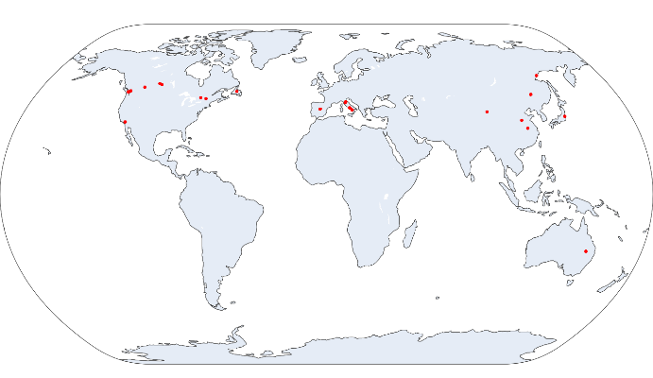

Figure 8: Geolocations of litter bag incubation sites

Add figure on performance of molecular mixing model

Scatter plot of response and predictors

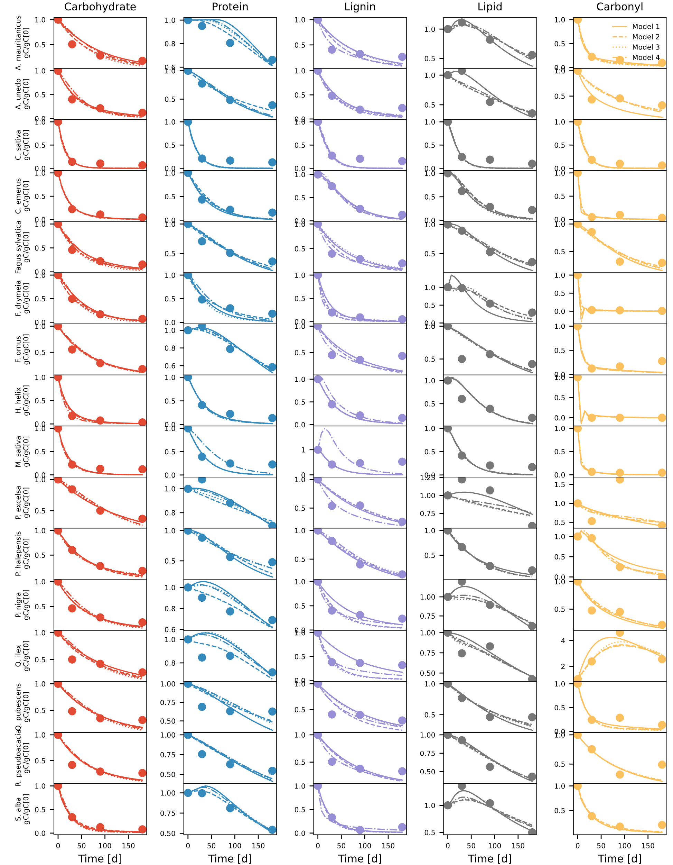

Figure 9 Comparison of modeled (different line styles) and observed (circles) changes in five litter pools (carbohydrate, protein, lignin, lipid, and carbonyl) for various litter samples compiled from Bonanomi et al. (2011; 2013). Different line styles are for four model variants. Model legends are the same as in Figure 3**.**

Figure 10 collinearity_Residual_Bonanomi et al 2011_P. halepensis (rate constants identifiable)

Figure 11 collinearity_Residual_Preston et al. 2009_Douglas-fir (rate constants and mLp identifiable)

Table S2 Chemical shift regions of five classes of organic compounds taken from Nelson and Baldock (2005)

|  |  |  |  |  |  |
| --- | --- | --- | --- | --- | --- |
| Chemical shift region (ppm) | Carbohydrate | Protein | Lignin | Lipid | Carbonyl |
| Alkyl C (0–45 ppm) | 0 | 39.6 | 10.5 | 75.6 | 0 |
| Methoxy (45–60 ppm) | 4.3 | 21.9 | 13.8 | 4.5 | 0 |
| O-alkyl (60-95 ppm) | 79 | 2.1 | 12.5 | 9 | 0 |
| Di-O-alkyl (95-110 ppm) | 15.7 | 0 | 8.6 | 0 | 0 |
| Aromatic (110-145 ppm) | 1 | 7.5 | 30.6 | 3.6 | 0 |
| Phenolic (145-165 ppm) | 0 | 2.5 | 19.5 | 0.7 | 0 |
| Carbonyl (165-210 ppm) | 0 | 26.4 | 4.6 | 6.6 | 100 |

Table S3 Elemental composition and nominal oxidation state of five classes of organic compounds from Baldock et al. (2004)

|  |  |  |
| --- | --- | --- |
| Organic compound | Elemental formula | NOSC |
| Carbohydrate |  | 0 |
| Protein |  | 0.034 |
| Lignin |  | -0.381 |
| Lipid |  | -1.47 |
| Carbonyl |  | 3 |